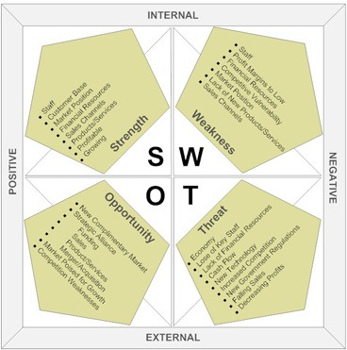

CAN YOU ADD ANYTHING TO THIS MATRIX?
WHAT MAY BE ANOTHER OPPORTUNITY OR THREAT?

